STEP by STEP After hardware assembled ver. 2.0

You may follow the procedure below

- Once schematic is complete, do PCB layout and order board. (10-30 hrs)
- Assemble board (solder everything on) (2-5 hrs)
  - Soldering iron, solder, and other needed materials can be found in the lab.
  - Be aware of the orientation of PLCC chips.
- Write VHDL code for board if using CPLD (2-30 hrs)
  - USB and parallel JTAG cables located in the lab.
  - Example code can be found in course documents and also the text book has examples of the use of the CPU signals.
- To program you ROM chips: (1 hr)
  - Assemble the X68 code using Easy68K program
  - Turn on the LabTool programmer and open the LabTool-68 software. Note there are two versions of the program, one if the ROM burner is connected via Parallel port and one if it's connected via USB.
  - Click on set device and select your ROM chip from the list.
  - Load your S68 code into the program selecting EVEN/ODD from file (depending on which chip you are programming) and keeping the ‘from buffer’ section set to ‘normal’. BE SURE TO NOT GET FROM FILE AND FROM BUFFER MIXED UP!!!!
  - Click program and repeat step d for the second ROM chip.
- Load loop program into Rom and test computer board (1-8 hrs)
  - Recommended loop program found in appendix A.
  - After loading program onto ROM, power up board and attach logic analyzer to AS and DTACK and look for the below waveform.
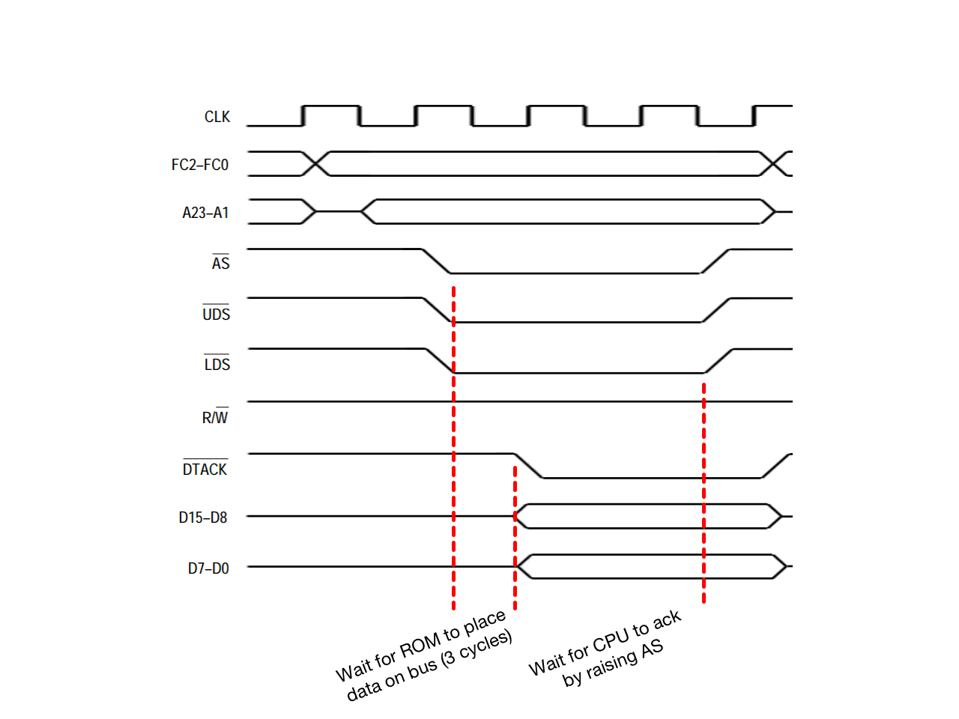
  - The simple loop program will run through about 4-5 lines of code and then jump back to the start. To verify this program worked connect the logic analyzer to the bottom of the address bus (A1-A8 & DTACK) and look for it to count up in binary and repeat.
  - Valid address’ only coincide with DTACK low signal.
- Troubleshoot hardware problems and get board working properly(10–80 hrs)
  - Possible flaws (in order of likelihood):
    - Verify upper and lower ROM chips are in correct sockets and were programmed correctly
    - Voltage lower than needed.
    - DTACK not programmed in VHDL correctly.
    - Decoding done incorrectly.
    - Schematic design errors.
    - Mistake on traces.
  - Test the RAM by using either subroutines (uses stack) or loading data into RAM. A program similar to the one for testing ROM is available in Appendix B for testing the RAM using a subroutine. Make sure to assign the stack pointer to a valid RAM location. Again, verify functionality via logic analyzer by looking for the address bus to count up.
  - Test DUART in auto-echo mode then normal mode. (See appendix C) This can be tested in HyperTerminal or PuTTy. Note that if you put the DUART in auto-echo, you cannot read/write data to/from the DUART.
  - Settings for HyperTerminal are your chosen baud rate, 8bit/char, no parity, 1 stop bit, and no flow control.

- Develop monitor program (20 – 60 hrs)
  - Get serial communication working with a PUTCHAR and GETCHAR subroutine (see the book).
  - Optionally use the code in appendix D to complete your monitor program primarily using the Easy68K emulator. Using the emulator makes tracing software errors much easier. Periodically test your code on your board to make sure it still works on your hardware. If you run into differences between the emulator and your hardware, make sure you have specified the size of each operation (byte, word, longword) as the physical CPU and emulator default to different sizes. If you use the code in appendix D, make sure to check you have switched the program back to hardware mode.
- Final test day with working hardware and software

Appendix A - ROM Testing

*-----------------------------------------------------------
* Program : Test Loop
* Written by : Instructor
* Date : 2010
* Description: Testing ROM. NOP is "No operation" and will
* simply increase the PC
*-----------------------------------------------------------

SUPER_STACK EQU $00FFE ;note this stack pointer points to a location in ROM and therefore will not function as a stack, it is simply used as a place holder.

START ORG $000000
DC.L SUPER_STACK
DC.L MAIN

ORG $000100
MAIN NOP
NOP
NOP
JMP MAIN

END MAIN
Appendix B - RAM Testing

*-----------------------------------------------------------
* Program : Test Loop
* Written by : Instructor
* Date : 2010
* Description: Testing RAM with a subroutine jump. To jump
* to a subroutine, the PC and SR are pushed onto
* the stack which is a location in RAM. If the
* program continually loops, the RAM is working
*-----------------------------------------------------------

SUPER_STACK EQU $80800 ; MUST BE A VALID RAM LOCATION

START ORG $000000
DC.L SUPER_STACK
DC.L MAIN

ORG $000100
MAIN JSR RAM_TEST
JUMP MAIN

RAM_TEST NOP
NOP
NOP
RTS

END MAIN

Appendix C

*-----------------------------------------------------------
* Subroutine : DUART enable
* Written by : Instructor
* Date : 2013
* Description: used to initialize a 68681 DUART
*-----------------------------------------------------------

* Note, most DUART configurations are ignorant of UDS/LDS
* and thus are only active on odd addresses (since the lower
* data lines are usually run to the DUART data bus)

; *******************************************************************
; Constants: (Note the offsets to account for no A0)
DUART EQU $020000 loaded in A0 when needed, regs are offsets
MR1A EQU 1 Mode Register1
MR2A EQU 1 points here after MR1A is set
SRA EQU 3 Status Register (read)
CSRA EQU 3 Clock Select Register
CRA EQU 5 Command Register
TBA EQU 7 Transfer Holding Register
RBA EQU 7 Receive Holding Register
ACR EQU 9 Auxiliary control register
RxRDY EQU 0 Recieve ready bit position
TxRDY EQU 2 Transmit ready bit position
BAUD EQU $CC baud rate value = 19,200 baud
; *******************************************************************

INIT_DUART LEA DUART,A0 A0 points to base DUART address

; Software reset:
MOVE.B #$30,CRA(A0) Reset TxA
MOVE.B #$20,CRA(A0) Reset RxA
MOVE.B #$10,CRA(A0) Reset MRA pointer

; Initialization:
MOVE.B #$80,ACR(A0) selects baud rate set 2
MOVE.B #BAUD,CSRA(A0) set 19.2k baud Rx/Tx
MOVE.B #$13,MR1A(A0) 8-bits, no parity, 1 stop bit

; This is the most important register to set in the 68681 DUART.
; 07 sets: Normal mode, CTS and RTS disabled, stop bit length = 1
; For testing load $#47 to enable auto-echo
MOVE.B #$47,MR2A(A0)

MOVE.B #$05,CRA(A0) enable Tx and Rx
RTS

Appendix D

Here is a little bit of code you can put in your monitor program to switch between simulating your code and running it on your hardware. The simulating software does not get keyboard text the same way as the DUART so this change in code is needed only for simulations.

RECOMMENDATION: Use this code once you have verified ROM, RAM, and DUART are function properly and you have working GETCHAR and PUTCHAR subroutines.

SIM EQU 1 ;0 = hardware state, 1 = simulation state

**************************************************

IF.B SIM <NE> #00 THEN.L ;when simulating, turn off keyboard echo
MOVE.B #$00,D1
MOVE.B #12,D0
TRAP #15
ENDI

**************************************************

*GCHAR gets an input character and stores is in D0

GCHAR IF.B SIM <EQ> #00 THEN.L

*INSERT YOUR HARDWARE GETCHAR CODE

ELSE

MOVE.L D1, -(SP)
MOVE.L #05, D0
TRAP #15
MOVE.B D1, D0
MOVE.L (SP)+, D1

ENDI

**************************************************
*PCHAR outputs the character on D0
PCHAR IF.B SIM <EQ> #00 THEN.L

*INSERT YOUR HARDWARE PUTCHAR CODE

ELSE

MOVE.L D0, -(SP) ; Task
MOVE.L D1, -(SP) ;Char to display
MOVE.B D0, D1
MOVE.L #06, D0
TRAP #15
MOVE.L (SP)+, D1
MOVE.L (SP)+, D0

ENDI
RTS

